**User Documentation**

**Fast Fiesta Ordering System Application**

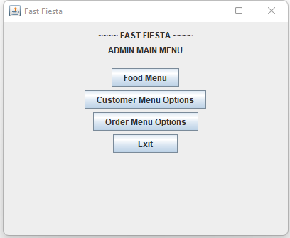

**Figure 1:** Admin Main Menu

When the app is launched, the Admin Main Menu appears (see Figure 1). It has four buttons options: the food menu, the customer menu option, the order menu option and exit. This, window, like all the others also has the standard have the close button, minimize and maximize button in the top left corner.

* **The food menu**

When an employee clicks on this option it would take them to a screen which shows the food options which are available (see Figure 2). There is also a ‘close’ option which would be used to exit the food menu screen.

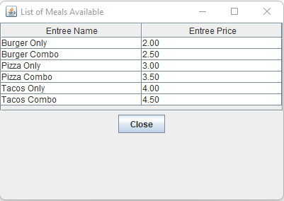

**Figure 2:** Food Menu Screen

* 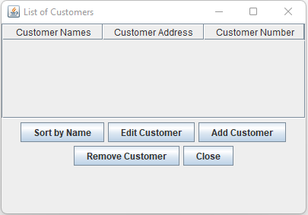**Customer Menu Option**

**Figure 3:** Customer Menu Option Screen

The user selects the customer menu option button from the main menu in order. Then a list of customers will be displayed and a number of buttons to choose from.

* + **Add Customer**

To add  a customer to this list the user can press the add customer button where they will be required to enter the customer’s name(both first and last), address and number.

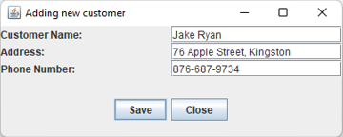

**Figure 4:** Add Customer Screen

* + **Edit Customer**

The customers in the list can be edited by pressing the edit customer button where they will be asked to enter the name of the customer to be edited as well as the new name, new address and new number. If the action was successful or not, a pop up window will appear informing the user appropriately as in all other parts of the app.

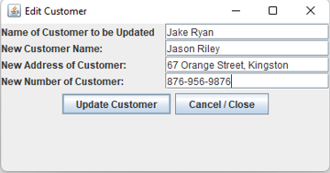

**Figure 5**: Edit Customer Screen

* + **Remove Customer**

If the user wants to remove a customer they can press the remove customer button where they will be asked to enter the name of the customer to be removed.

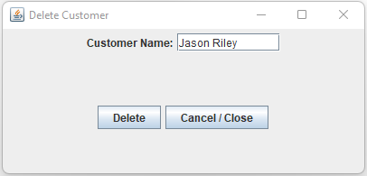

**Figure 6: Delete Customer Screen**

* + **Sort by Name**

If the user wants to sort the customer list in alphabetical order by name they can use the sort by name button.

* **Order Menu Option**

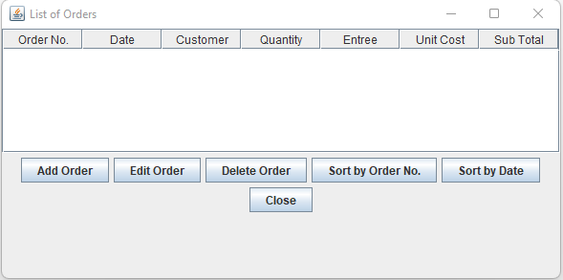

**Figure 7:** Order Menu Option Screen

When the user clicks on the order menu option it leads to a screen with a list of orders containing information such as the order number, the date the order was made in format year-month-day, the customer’s name, the quantity of food item the food item ordered, the unit cost of the item and the subtotal which is the quantity of food times the unit cost of the food (see Figure 7).

* + **Add Order**

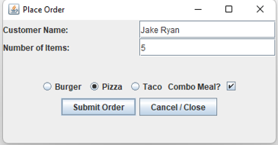

**Figure 8**: Add Order Screen

The add order button used if the user wants to add an order by entering the customer’s name using alphabet characters (both first and last), the number of items needed which can only be numeric values. The user then has to choose the meal by selecting want out of the three options and if the user wants to have a combo they can click the combo meal checkbox. When finished, the user should then press submit order and a receipt would then appear. The user also has the option to cancel before submitting and leave the window by via pressing the cancel or close button to exit the window.

* + - 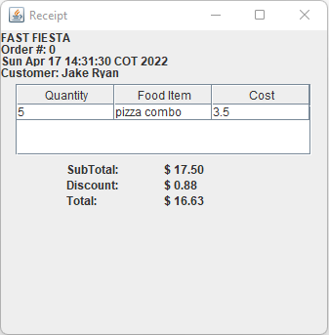**Receipt**

**Figure 9:** Receipt Generated from Order

In the new window where the receipt appears shows the name of the restaurant, the order number, the date and the customer's name. There is also a table which shows the quantity, the food order and cost, and what the customer ordered is displayed in the table, the subtotal price, total price and discount is also shown. All customers get a five percent discount and the total would be the price after the discount is taken from the subtotal.

* + **Edit Order**

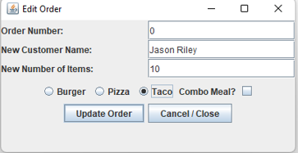To edit an order the order number must be entered in the text box, then the user would enter the new customer name and the new number of items, select the food item desired. When done, click update order button and if at any point the user wishes not to update order, click cancel.

**Figure 10**: Edit Order Screen

* + **Delete Order**

To delete an order the user enters the order number which for which they would like to delete, and then click the delete button. There is the close or cancel button for if they do not wish to delete.

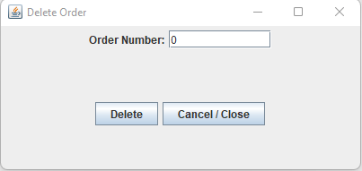

**Figure 10**: Delete Order Screen

* + **Sort**

Sort by Order No. button sorts the list of orders in ascending order using the order number.

Sort by Date sorts in descending order for date (most current date appears first).

* **Exit**

Click this button to terminate use of the app.